**Practical No :-03**

**Aim:-** Scheduling Project

**Brain Disease Prediction System using Machine Learning.**

**. Identifying Tasks**

* **Data Collection**: Gather datasets (MRI scans, patient records, etc.).
* **Data Preprocessing**: Cleaning, normalization, and feature extraction.
* **Model Selection**: Choose between CNN, Random Forest, XGBoost, etc.
* **Model Training & Validation**: Hyperparameter tuning, testing performance.
* **Deployment Planning**: Web app (Flask/Django) or cloud-based deployment (AWS).
* **Testing & Debugging**: Ensure system accuracy and efficiency.
* **Final Evaluation & Documentation**: Prepare project reports and final checks.

**2. Identifying Resources**

* **Hardware**: GPU-enabled systems for deep learning models.
* **Software & Tools**: Python, TensorFlow/Keras, Scikit-learn, AWS/GCP.
* **Data**: Public datasets like OASIS, ADNI, or private hospital records.
* **Team Members**: Data scientists, software engineers, domain experts.

**3. Schedule Using Gantt Chart**

A **Gantt chart** will help visualize timelines. You can use:

* **MS Project, Trello, Asana, or Excel** for chart creation.
* **Week-wise planning** (e.g., Data Collection: Week 1-2, Model Training: Week 5-7, Deployment: Week 10-12).

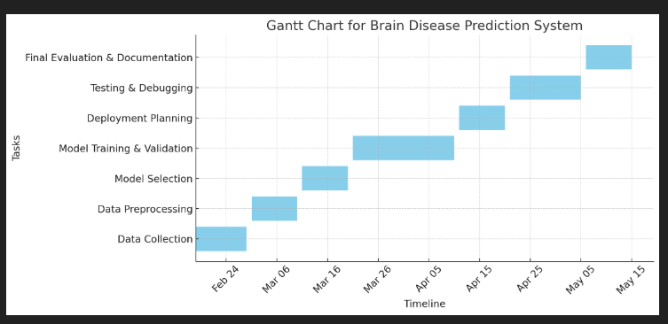

**Key Points:**

* **Tasks on Y-axis**: Each task (e.g., Data Collection, Model Training) is listed vertically.
* **Timeline on X-axis**: Dates from **Feb 18, 2025, to May 15, 2025** are displayed.
* **Bars represent task duration**:
  + **Data Collection (Feb 18 - Feb 28)** kicks off the project.
  + **Preprocessing & Model Selection (March 1 - March 20)** follows.
  + **Model Training & Validation (March 21 - April 10)** takes the longest.
  + **Deployment Planning, Testing & Debugging (April 11 - May 5)** ensures smooth implementation.
  + **Final Evaluation (May 6 - May 15)** wraps up the project.

The chart helps in tracking progress, identifying overlapping tasks, and ensuring deadlines are met efficiently.